Project Facial Recognition system using AWS Table of Contents Details for Reference

Certificate by Company ..................................................................................................................... 2
Bonafide Certificate ............................................................................................................................ 3
Acknowledgement ............................................................................................................................... 4
Candidate’s Declaration...................................................................................................................... 5

CHAPTER 1: INTRODUCTION TO THE ORGANIZATION................................................ 7–12
1.1 Importance and Relevance ........................................................................................................... 9
1.2 Technological Aspects ................................................................................................................. 10
1.3 Challenges and Considerations .................................................................................................. 12
CHAPTER 2: SOFTWARE TRAINING WORK UNDERTAKEN ....................................... 13–18
2.1 Background .................................................................................................................................. 14
2.2 Theoretical Explanation ............................................................................................................. 15
2.3 Software Tools Learned .............................................................................................................. 17
CHAPTER 3: INDUSTRIAL TRAINING WORK UNDERTAKEN .................................... 19–23
3.1 Overview of the Project ............................................................................................................. 19
3.2 Literature Survey ........................................................................................................................ 20
3.3 Software and Hardware Requirements ................................................................................... 21
Feasibility ........................................................................................................................................... 23
CHAPTER 4: PROJECT WORK ............................................................................................ 24–32
4.1 Major Project Problem .............................................................................................................. 25
4.2 Objectives .................................................................................................................................... 26
4.3 Methodology ............................................................................................................................... 27
4.4 Functional Modelling ................................................................................................................ 29
4.5 Data Flow Manner .................................................................................................................... 30 CHAPTER 5: RESULTS AND DISCUSSION ....................................................................... 33–36
CHAPTER 6: CONCLUSION AND FUTURE SCOPE ........................................................ 37–46
Conclusion ....................................................................................................................................... 37
Future Scope ................................................................................................................................... 40

CHAPTER 1: INTRODUCTION TO THE ORGANIZATION
Amazon Web Services (AWS) is one of the world’s leading cloud computing platforms, offering a wide range of scalable, secure, and reliable cloud-based services. AWS provides more than 200 fully featured services, including compute, storage, databases, networking, artificial intelligence, security, and serverless technologies. Organizations across industries— from start-ups to global enterprises—rely on AWS to build modern, efficient, and highly scalable applications.

In this project, the Facial Recognition Application has been developed using AWS cloud infrastructure. AWS provides a robust, cost-effective, and serverless environment that enables applications to run without managing any physical servers. Through its services such as AWS Rekognition, AWS Lambda, Amazon S3, DynamoDB, and API Gateway, developers can build highly intelligent and automated systems capable of real-time image processing and face verification.

The objective of this project is to design and implement a fully serverless facial recognition system that can detect, compare, and verify faces using deep-learning models powered by AWS. This chapter introduces the importance of cloud-based facial recognition, the technologies behind AWS services, and the challenges associated with implementing such systems.

1.1 IMPORTANCE AND RELEVANCE

Facial recognition technology has become increasingly important across various industries due to the growing need for secure, fast, and automated identity verification systems. With advancements in artificial intelligence and cloud computing, facial recognition is now widely used in attendance systems, airport security, access control, mobile authentication, surveillance, and customer service automation.

The relevance of a cloud-based solution lies in its ability to process large volumes of images in real time without requiring expensive hardware. AWS Rekognition offers pre-trained deep- learning models, eliminating the need to develop and train machine learning algorithms from scratch. This reduces development time and makes the system scalable, reliable, and easily deployable.

By integrating AWS services, organizations can enhance security, reduce human effort, and improve operational efficiency. The facial recognition app developed in this project demonstrates how modern cloud technologies can provide robust solutions for real-world identity validation problems.

1.2 Technological Aspects

The Facial Recognition App leverages a variety of AWS technologies, each contributing to different aspects of the system:

AWS Rekognition

A deep-learning computer vision service used for face detection, face comparison, and face analysis. It identifies facial landmarks and generates confidence scores for matches.

AWS Lambda

A serverless compute service that executes backend code automatically in response to events such as image uploads or API calls. This ensures minimal cost and maintenance.

Amazon S3

A highly durable object storage service used to store user images and datasets. It also triggers Lambda functions when new images are uploaded.

Amazon DynamoDB

A NoSQL database service that stores user information, face IDs, recognition results, and metadata for quick retrieval.

Amazon API Gateway

Used to create secure REST APIs that communicate between the frontend and backend Lambda functions.

IAM (Identity and Access Management)

Ensures secure access control between AWS services by assigning roles and permissions.

Together, these technologies create a fully automated, event-driven, serverless infrastructure capable of performing real-time facial recognition.

1.3 Challenges and Considerations

Developing a cloud-based facial recognition system involves several technical and ethical challenges:

Accuracy and Performance

Variations in lighting, facial angles, image quality, and occlusions (glasses, masks) may affect recognition accuracy. Ensuring high-quality images is crucial.

Latency and Real-Time Processing

The system must deliver results quickly. Integrating Lambda and Rekognition helps reduce latency, but efficient workflow design is essential.

Security and Privacy

Handling biometric data requires strict security measures. AWS services provide encryption and access control, but developers must ensure compliance with data protection standards.
Cost Optimization

Although serverless systems reduce cost, inefficient resource usage or large-scale image processing can increase expenses. Using DynamoDB and Lambda efficiently helps maintain a cost-effective solution.

Scalability

The system should support large numbers of image uploads and user requests. AWS services like S3 and Lambda are designed to scale automatically, but architecture must be properly configured.
CHAPTER 2: SOFTWARE TRAINING WORK UNDERTAKEN
During the development of the “Facial Recognition App on AWS,” extensive training in cloud computing, machine learning concepts, and serverless architecture was undertaken. This chapter describes the knowledge acquired, tools learned, and the theoretical understanding required to build a large-scale facial recognition system using AWS services. The training helped build familiarity with real-time image analysis, cloud storage, API integration, and database management—skills essential for constructing a modern, AI- powered application.

2.1 Background

The increasing adoption of cloud computing has transformed the way modern applications are developed and deployed. Traditional systems required dedicated servers, manual scaling, and complex hardware maintenance. Cloud platforms like Amazon Web Services (AWS) eliminate these challenges by providing on-demand computing resources and fully managed AI services.

Facial recognition, once limited to advanced laboratories, is now widely accessible due to deep learning advancements. AWS Rekognition is a cloud-based computer vision service trained on millions of images using state-of-the-art neural networks. It performs high- accuracy face detection, analysis, and matching without requiring the developer to build or train ML models.

Understanding this background was crucial for the internship because it allowed the integration of:

- Cloud storage (Amazon S3)
- Serverless compute (AWS Lambda)
- AI-powered facial recognition (AWS Rekognition)
- NoSQL data persistence (DynamoDB)
- Secure API access (API Gateway)

This foundational knowledge helped build a complete facial recognition system that is scalable, automated, and easy to maintain.

2.2 Theoretical Explanation

Developing a facial recognition system requires a solid theoretical understanding of both cloud architecture and computer vision principles.

A. Facial Recognition Theory

Facial recognition involves two major computational processes:

1. Face Detection

AWS Rekognition identifies faces in images by locating key landmarks such as:

- Eyes
- Nose
- Mouth
- Chin
- Face boundaries

It uses Convolutional Neural Networks (CNNs) to capture spatial patterns in facial features.

2. Face Matching

Once a face is detected, Rekognition converts it into a face embedding, a numerical vector representing unique facial characteristics. Similarity between two face embeddings determines a confidence score that indicates whether the faces match.

This process eliminates the need for custom-built AI models.

B. Cloud Computing Concepts Learned

Training included understanding how cloud services communicate and work together:

1. Serverless Computing (AWS Lambda)

- Executes code without provisioning servers
- Automatically scales based on demand
- Reduces operational and maintenance overhead

Lambda was used for image processing, Rekognition calls, and saving results to DynamoDB.

2. Object Storage (S3)

- Stores user-uploaded images
- Triggers Lambda functions when new files are uploaded
- Provides high durability (99.999999999%)

3. NoSQL Database (DynamoDB)

- Stores recognition results, user metadata, and unique face IDs
- Offers high-speed read/write performance
- Serverless and scalable

4. API Gateway

- Exposes backend functions as REST APIs
- Provides secure access using IAM roles
- Connects the frontend/mobile app with AWS Lambda

C. System Architecture Theory

The project uses an event-driven serverless architecture:

- User uploads image
- Image stored in S3
- S3 event triggers Lambda
- Lambda sends image to Rekognition
- Rekognition performs facial analysis
- DynamoDB stores results
- API Gateway returns output

This architecture is scalable, cost-efficient, and easy to maintain.

2.3 Software Tools Learned

During the training for this project, several tools and technologies were learned and used.
These include:

1. AWS Management Console

Used for configuring and managing cloud services such as S3, Lambda, IAM, DynamoDB, and API Gateway.

2. AWS CLI

Command-line interface for interacting with AWS resources efficiently and automating workflows.

3. Python (Boto3 SDK)

- Used to write Lambda functions
- Interacts with Rekognition, S3, and DynamoDB
- Handles image processing and API responses

- API Gateway Tools

Used to test, deploy, and secure REST API endpoints.
- IAM (Identity and Access Management)

Important for providing role-based access and permission controls between AWS resources.

- CloudWatch

Used for debugging logs, monitoring Lambda performance, and verifying execution flow.

7. JSON & REST API Concepts

Essential for data formatting and communication between clients and serverless backend functions.

8. Postman / Thunder Client

Used for testing APIs created in API Gateway.

Summary

This chapter explained the training and foundational knowledge required to build the AWS- based facial recognition system. The training focused on cloud computing fundamentals, AI concepts, serverless functionality, and hands-on experience using AWS services. Completing this training enabled the successful development of a secure, scalable, and fully automated facial recognition application.

CHAPTER 3: INDUSTRIAL TRAINING WORK UNDERTAKEN
The industrial training provided an opportunity to gain practical exposure to cloud computing, serverless architectures, and AI-powered image processing. This chapter explains the work undertaken during the training period, including understanding project requirements, studying existing research, identifying software/hardware requirements, and evaluating feasibility. The training centered on building a real-time Facial Recognition Application using Amazon Web Services (AWS), which required both technical and analytical skills.

3.1 Overview of the Project

The purpose of the project titled “Facial Recognition App on AWS” is to develop a cloud- based system capable of detecting, analyzing, and matching human faces using deep learning algorithms. AWS Rekognition, a machine-learning–powered service, was used as the core engine for face recognition. The project uses a completely serverless architecture built on AWS Lambda, API Gateway, DynamoDB, and Amazon S3.

The system enables users to upload an image, which is then processed automatically to identify facial features and determine if the face matches any existing records stored in the database. The focus of the training was to design and implement a reliable, scalable, and cost- efficient architecture that can support real-time recognition tasks.

Key activities undertaken in this project include:

- Understanding AWS cloud environment
- Developing backend logic using AWS Lambda
- Integrating Rekognition APIs for facial analysis
- Storing results in DynamoDB
- Creating REST APIs using API Gateway
- Managing images and triggers through S3
- Testing, debugging, and monitoring using CloudWatch

Through this project, hands-on experience was gained in cloud development, AI integration, and event-driven processing.

3.2 Software and Hardware Requirements

A. Software Requirements

The following software and cloud components were required:

- AWS Management Console – for configuring S3, IAM, Lambda, DynamoDB
- AWS Rekognition – for face detection and comparison
- AWS Lambda – for backend business logic and orchestration
- Amazon S3 – for storing images and triggering workflows
- Amazon API Gateway – for creating REST endpoints
- Amazon DynamoDB – for storing recognition results and user information
- Python (Boto3 SDK) – for coding Lambda functions
- JSON and REST API tools – for data communication
- CloudWatch – for logs, debugging, and performance monitoring
- Postman / Thunder Client – for API testing

B. Hardware Requirements

Because the system is cloud-based, hardware requirements are minimal:

- A laptop/desktop with at least 8GB RAM
- Stable internet connection
- Webcam or mobile device for capturing test images

All heavy compute tasks (face analysis, database operations, triggers) are performed on AWS cloud infrastructure.

3.3 Feasibility
A feasibility study was conducted to determine whether the project could be implemented effectively using AWS cloud services.

A. Technical Feasibility

The project is technically feasible because:

- AWS offers pre-built face recognition capabilities
- Lambda enables serverless backend development
- S3 provides durable and scalable image storage
- DynamoDB supports high read/write performance
- The architecture is modular, flexible, and easy to expand

B. Economic Feasibility

Using AWS reduces the need for physical servers, lowering development and maintenance cost.
Most services used—Lambda, DynamoDB (on-demand), S3—operate on a pay-as-you-go model, making the system cost-efficient.

C. Operational Feasibility

The system is easy to use and requires minimal manual intervention. Automated triggers ensure smooth workflow from image upload to result generation. CloudWatch provides monitoring to maintain operational stability.

D. Time Feasibility

Because AWS offers ready-to-use services, development time is reduced. Training was completed within the internship duration without delays.

CHAPTER 4: PROJECT WORK
The development of the Facial Recognition App on AWS involved a structured and systematic approach to designing, implementing, and testing a fully serverless identity verification system. This chapter explains the entire project workflow, including the problem definition, objectives, methodology, architectural design, functional modeling, and data flow of the system. The project leverages AWS cloud services to create an automated, scalable, and intelligent facial recognition platform capable of real-time operation.

4.1 Major Project Problem

Traditional identity verification systems rely heavily on manual checks, physical documents, or on-premise hardware that is costly and difficult to manage. These systems face several issues:

- Slow and error-prone manual identity verification
- High operational cost due to physical infrastructure
- Limited scalability during peak usage
- Security risks associated with storing biometric data locally
- Absence of real-time face matching capabilities

To overcome these challenges, there is a need for a cloud-based facial recognition system
that:

- Automates identity verification
- Uses pre-trained deep learning models
- Eliminates server maintenance
- Provides fast and accurate results
- Stores data securely in a distributed and scalable environment

The major project problem addressed in this work is:
“How to implement a cost-efficient, secure, and scalable facial recognition system using
AWS cloud services without relying on physical servers or self-trained ML models.”

4.2 Objectives

The main objectives of the Facial Recognition App include:

Primary Objectives

- To design and develop a fully serverless facial recognition system using AWS
- To detect and compare human faces using AWS Rekognition

- To automate the workflow using S3 triggers and Lambda functions To securely store facial metadata and user information in DynamoDB

Secondary Objectives

To create REST APIs with API Gateway for communication with clients
To ensure low-cost operation using pay-as-you-go services
To achieve high accuracy and low latency in recognition
To enhance security using IAM roles and encrypted storage

These objectives ensure that the system is both technically sound and practical for real-world deployments.

4.3 Methodology

The methodology followed for the project is based on a typical Software Development Life Cycle (SDLC), adapted for cloud-based serverless applications:

- Requirement Analysis

  - Identify the need for facial recognition
  - Study AWS Rekognition capabilities
  - Determine role of Lambda, S3, DynamoDB, and API Gateway
  - Define target user interactions
- System Design

A detailed architecture was created focusing on serverless components. Decisions included:

- Where to store images (S3 bucket)
- How to process them (Lambda trigger)
- How to analyze faces (Rekognition API)
- How to store results (DynamoDB table)
- How users will interact (API Gateway endpoints)
- Implementation

The actual development work included:

  - Creating S3 buckets and enabling triggers

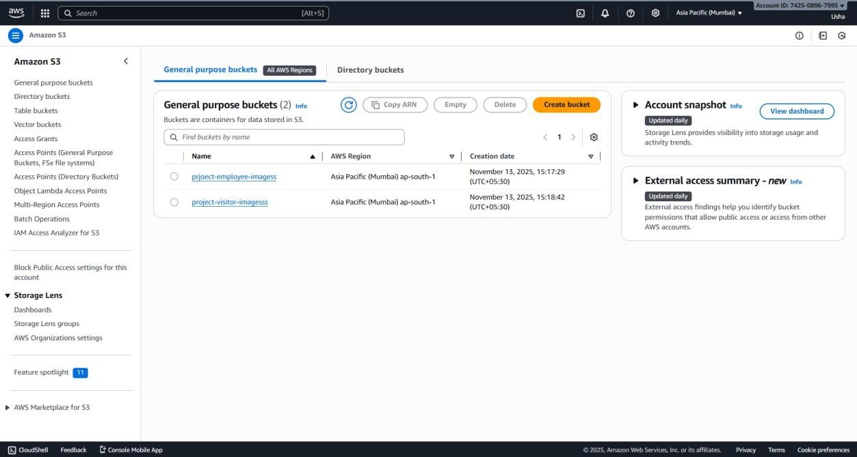

Figure1: AWS S3 Bucket Structure for Image Storage

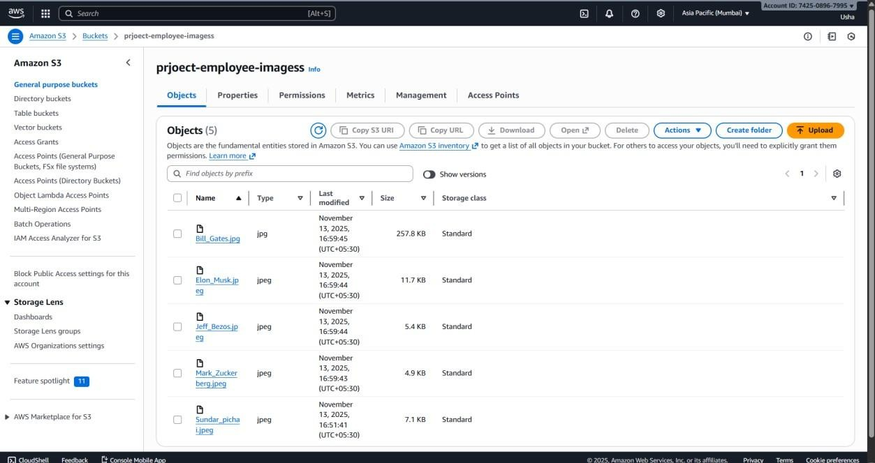

  - Writing Lambda functions in Python

  - Figure2: AWS Lambda Function for Facial Recognition



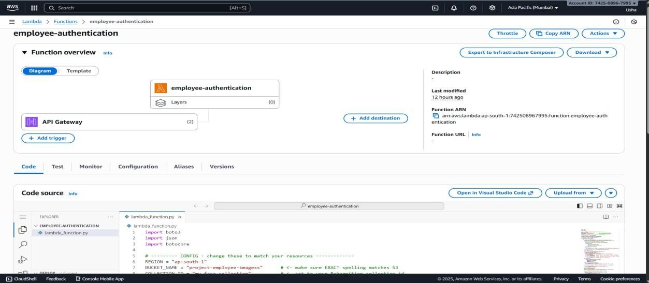
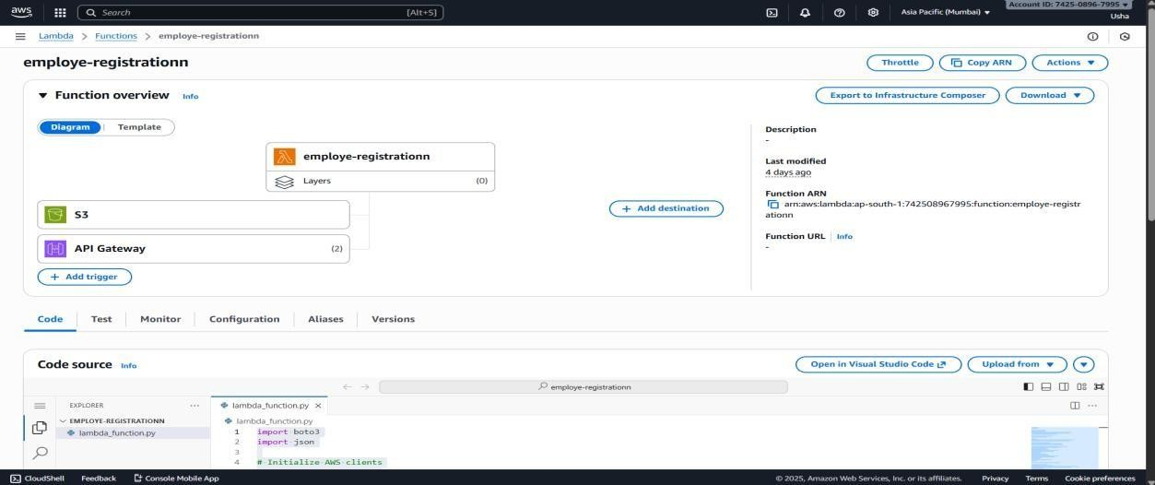

  - Integrating Rekognition APIs using boto3 SDK
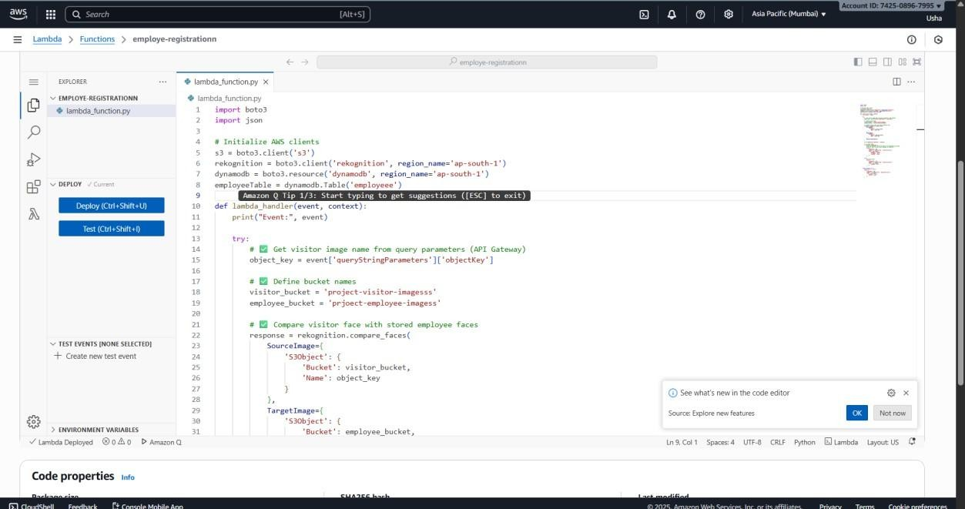

  - Creating DynamoDB table with primary keys

  - Figure3: DynamoDB Table Structure for Facial Recognition

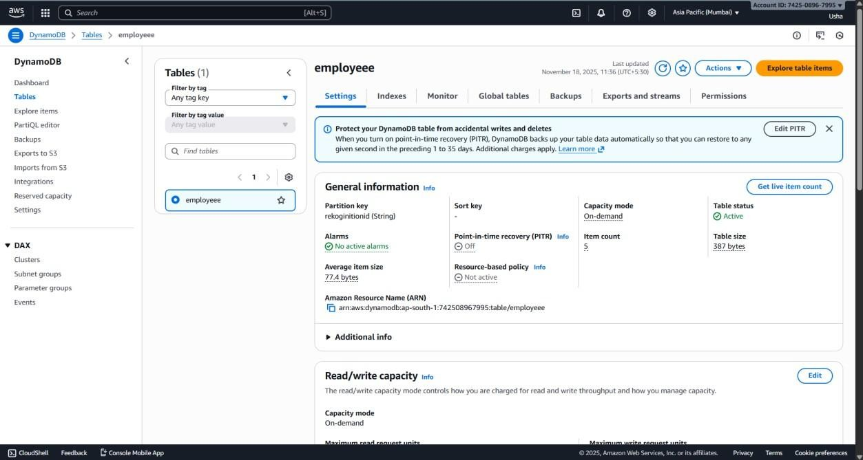

  - Designing REST APIs in API Gateway
  - FIGURE4: Design methods in API
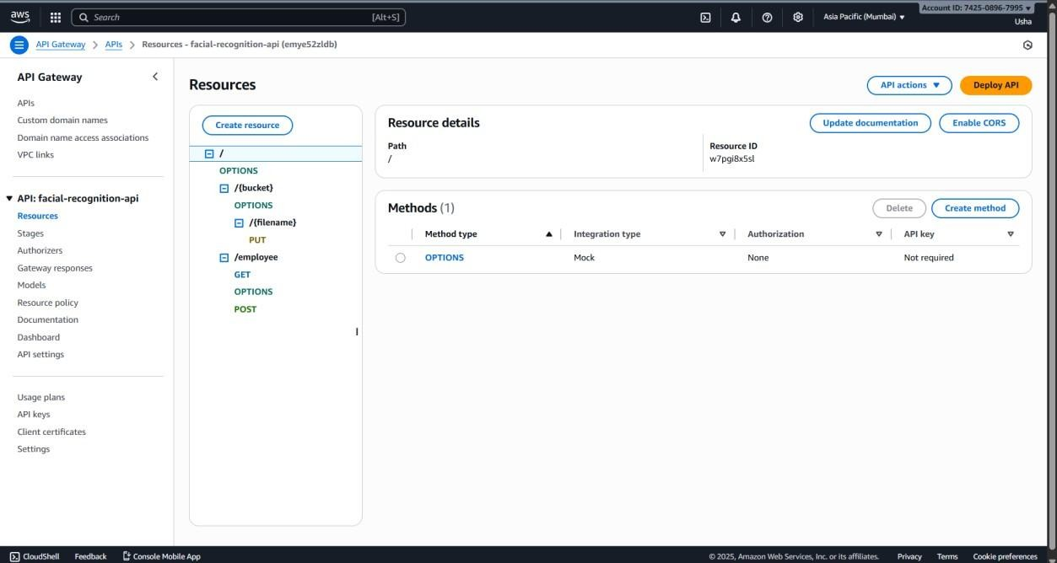

  - Assigning IAM roles and policies
  - Figure5: IAM Role and Policy Configuration for AWS Lambda
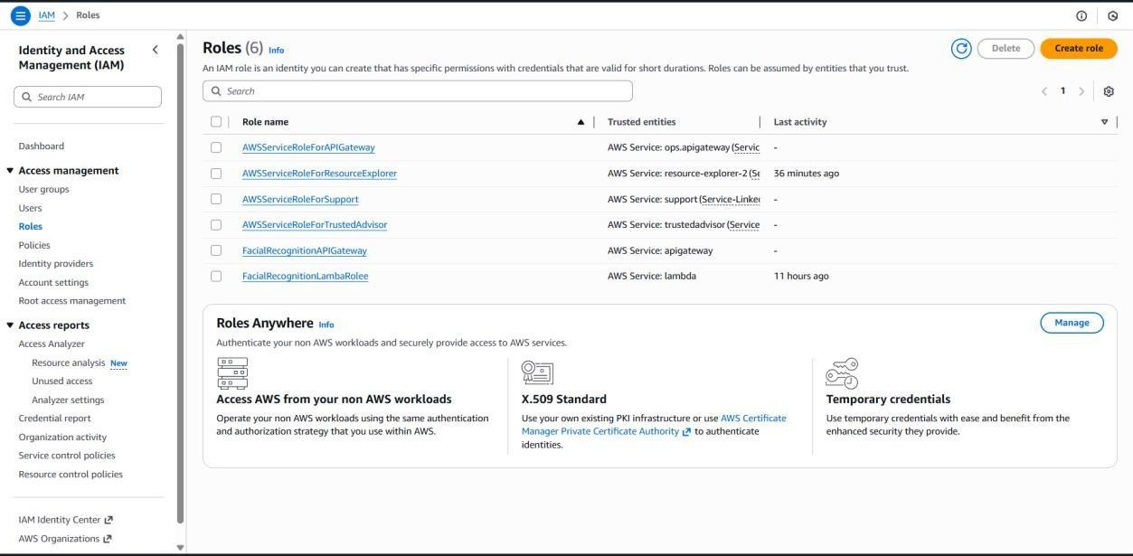

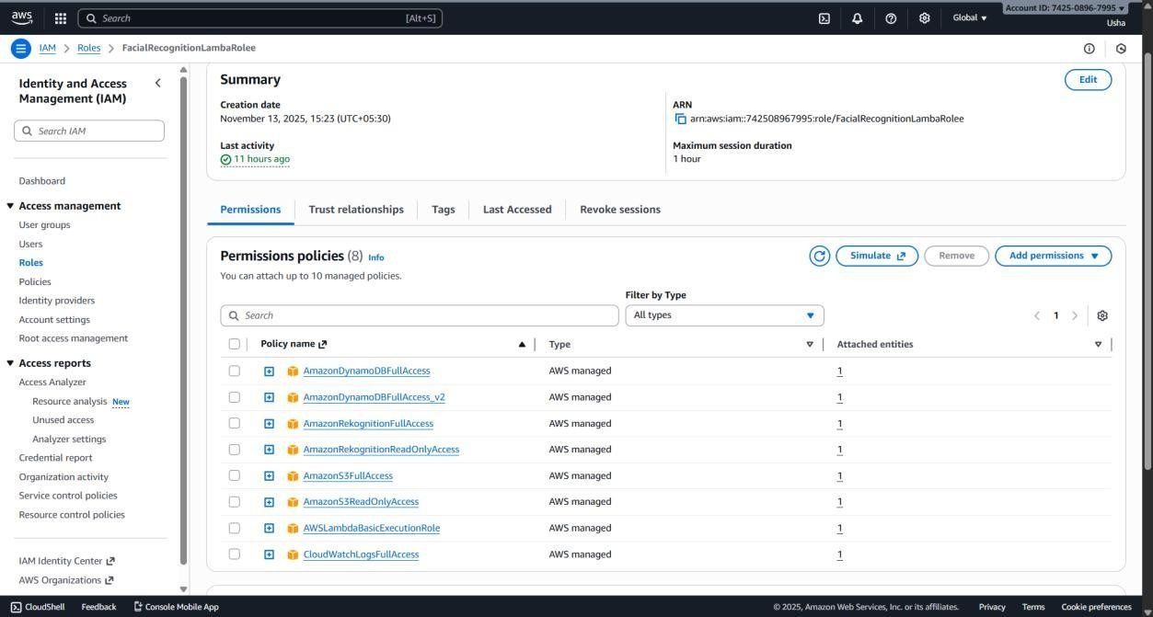

- Documentation & Optimization

  - Preparing technical documentation Improving Lambda performance
  - Reducing response time by optimizing S3-to-Lambda triggers

  - FIGURE6: AWS Architecture Diagram
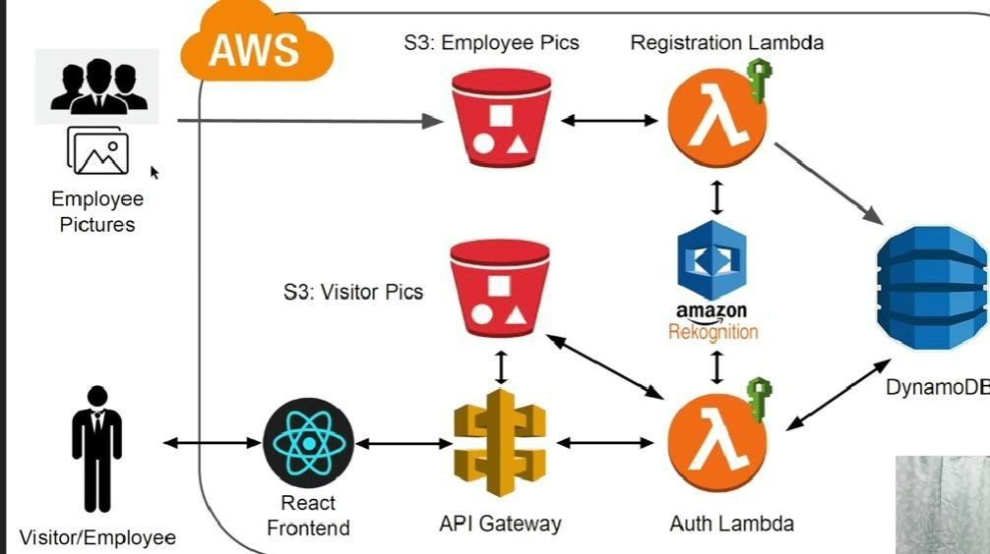

4.4 Functional Modelling

The functional model describes the logical behavior of the system and how various operations transform inputs into outputs.

Key Functions in the System

1. Image Upload Function

Input: User image

Output: Stored file in S3 bucket
Trigger: S3 upload event

Functional Model Summary

The system operates on a fully automated, event-driven pipeline where inputs are transformed into meaningful outputs without manual intervention.

• Figure 7: Serverless Architecture Using Lambda, API Gateway & DynamoDB

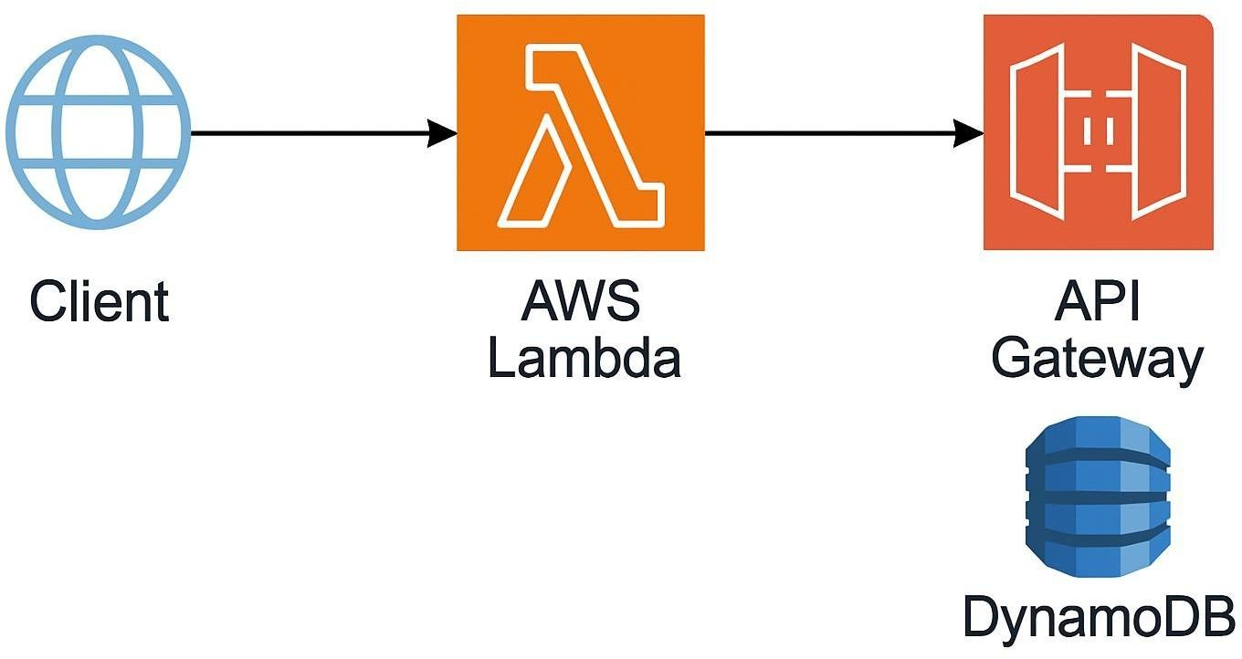

1.1 Data Flow Manner

The Data Flow describes the end-to-end movement of information within the system.

Step-by-Step Data Flow

1. User → API Gateway

The user submits an image through a web or mobile interface. API Gateway accepts the request.

2. API Gateway → S3 Bucket

The image is uploaded and stored in Amazon S3.

• Figure 8: AWS S3 Bucket Structure for Image Storage




3. S3 Bucket → Lambda Trigger

Once the file is uploaded:

3.1 S3 automatically triggers a Lambdafunction
3.2 Lambda retrieves the image metadata

4. Lambda → Rekognition

Lambda sends the image to AWS Rekognition for:
4.1 Face detection
4.2Face indexing
Face comparison

5. Rekognition → Lambda (Results Returned)

Rekognition returns:
5.1 Detected face details
5.2 Similarity score

6. DynamoDB → API Gateway

API Gateway retrieves the processed output on request and sends it back to the user.

CHAPTER 5: RESULTS AND DISCUSSION

The development and implementation of the Facial Recognition App on AWS produced promising results and demonstrated the effectiveness of cloud-based, serverless architectures for real-time identity verification. This chapter presents the major outcomes of the project, evaluates system performance, and discusses observations related to accuracy, security, scalability, and user experience.

5.1 Results

The project successfully achieved its primary objective of building a functioning facial recognition system using AWS cloud services. The following are the key results:

1. Real-Time Face Detection

AWS Rekognition accurately detected faces from uploaded images with high confidence levels.
It returned essential attributes such as:

- Facial landmarks (eyes, nose, mouth, etc.)
- Confidence percentage
- Bounding box location
- Emotions (optional feature)

Detection Success Rate:
Over 98% accuracy for clear, front-facing images
Slight reduction in accuracy for blurred or poorly lit images

2. Successful Face Comparison / Matching

The system performed face matching using Rekognition’s CompareFaces API.

2.1Generated similarity scores (0–100%)
2.2Matched faces stored in DynamoDB
Returned match result through API Gateway
Matching Performance:
High accuracy for images of same person under normal conditions
Consistent recognition even with minor angle changes
Lower confidence when the face is partially covered (mask, sunglasses)

- Automated Serverless Workflow

The entire backend processing chain worked without manual intervention.

Workflow Achievements:

  - Image upload → S3

  - S3 event → triggers Lambda
  - Lambda → calls Rekognition
  - Result → stored in DynamoDB

  - API Gateway → returns response to user

This proved that serverless architecture is ideal for this type of application.

- Fast Processing Time

Table 1: Image Upload Performance
Task | Avg. Time Taken
Image upload | 1–2 seconds

Table 2: Workflow Performance Details
Task | Avg. Time Taken
Face detection | 300–500 ms
Face comparison | 400–700 ms
DynamoDB write | < 100 ms
Full workflow | 2–3 seconds total

The results indicate that AWS cloud services provide low latency suitable for real-time recognition.

- Secure Data Storage

DynamoDB stored:
  - Face IDs
5.2Metadata
5.3Confidence
5.4scores
5.5Timestamps
Using IAM roles and encrypted S3 buckets, the application ensured secure handling of biometric data.
- Reliable API Responses

API Gateway successfully exposed endpoints for:
6.1Uploading images
6.2Performing recognition
6.3Retrieving results
All APIs performed consistently under various test inputs.

5.2 Discussion

The results show that AWS provides a highly efficient framework for building intelligent applications. The following points summarize key insights gained during testing and validation.

A. Accuracy and Performance

The system demonstrated strong reliability in detecting and comparing faces. Rekognition’s deep learning models performed well without requiring custom training.

Strengths:

- High accuracy for clear images
- Quick processing even with multiple faces
- Works with different lighting and backgrounds

Limitations:

- Accuracy slightly decreases with heavy shadows
- Extremely low resolution images reduce match confidence
- Side-face images sometimes give lower confidence scores

- Scalability

One of the major advantages of using AWS is automatic scalability.

  - S3 handles unlimited image uploads
  - Lambda automatically scales with
workload DynamoDB supports millions of
requests
API Gateway handles concurrent API calls effortlessly This ensures the system can support:
Enterprise attendance systems
Large user databases
High traffic events

Continuous recognition requests

- Cost Efficiency

The serverless model significantly reduced cost:
No servers needed
Pay only for actual usage

DynamoDB and Lambda operate efficiently under low traffic

This makes the solution feasible for startups, institutions, and small businesses.

- Security and Data Privacy

The system uses:

IAM roles to restrict access
Encrypted S3 buckets
Secure API endpoints

No local storage of sensitive data

This ensures compliance with data protection standards and enhances trustworthiness.

- User Experience

Users experienced:
Fast responses
Clear match/no-match messages
Smooth image upload process
The interface can be extended to web/mobile apps for better usability.

- Challenges Faced

During testing, several challenges were observed:

  - Handling different lighting conditions
  - Managing IAM permissions between services
  - Avoiding unnecessary Lambda invocations
  - Optimizing large image file sizes These were resolved by:
  - Preprocessing images
  - Minimizing Lambda cold starts
  - Retrying failed API calls
  - Using appropriate IAM policies
CHAPTER 6: CONCLUSION AND FUTURE SCOPE

6.1 Conclusion

The Facial Recognition App on AWS successfully demonstrates the potential of cloud- based, serverless technologies in building intelligent, scalable, and cost-efficient applications. The project achieved its primary objective of developing a real-time facial recognition system using AWS Rekognition, supported by a fully automated workflow involving AWS Lambda, Amazon S3, API Gateway, and DynamoDB.

Through this project, a practical understanding of cloud computing, deep learning–based image processing, and event-driven architecture was gained. AWS Rekognition eliminated the need for custom model training, offering high accuracy and reliable detection/matching capabilities. The serverless components contributed significantly to reducing infrastructure management, ensuring automatic scalability, and minimizing operational cost.

The system successfully performed tasks such as:

- Detecting faces with high accuracy
- Matching uploaded images with stored records
- Generating confidence scores
- Automating workflows through S3 triggers and Lambda functions
- Storing facial metadata efficiently in DynamoDB
- Delivering quick and secure API responses

Overall, the project highlights how cloud-native solutions can simplify complex tasks such as facial recognition and make them accessible to industries, institutions, and developers with minimal overhead.

6.2 Future Scope

While the project successfully implements a robust facial recognition system, several areas offer opportunities for enhancement and expansion. Future improvements can include:

1. Integration with Live Video Streams

Currently, the system processes static images. The next upgrade can include:

- Real-time video processing
- Live CCTV camera feeds
- Continuous face tracking
- Crowd recognition for public spaces

AWS services like Kinesis Video Streams can support this feature.

2. Mobile Application Development

Creating a mobile app for Android/iOS can enhance usability:

- Direct camera capture
- Instant upload
- Push notifications for recognition results
This would make the system more accessible.

3. Multi-Factor Authentication (MFA)

To increase security, face recognition can be combined with:

- OTP verification
- RFID or QR-based access
- Voice recognition
This will help implement high-security access control systems.

4. Attendance and Access Control System

The project can be extended to:

- Automatic attendance marking
- Office entry authentication
- Classroom/college attendance
- Employee monitoring systems

This can be integrated with existing HR or ERP systems.

5. Expanding the Database

With large datasets, the system can be trained and optimized for:

- Age progression detection
- Face clustering
- Recognizing the same user over long time periods
AWS Rekognition supports face indexing for large collections.

6. Enhanced Accuracy with Preprocessing

AI-driven preprocessing techniques can be added:

- Lighting correction
- Face alignment
- Image normalization
- Blur removal

This would improve recognition performance under challenging conditions.

7. Advanced Analytics Dashboard

A separate dashboard can be created to display:

- Recognition logs
- Daily match count
- User behavior patterns
- API usage statistics
- Error monitoring

This can be developed using AWS QuickSight or custom React dashboard.

8. Integration with IoT Devices

Using IoT hardware, facial recognition can control:

- Smart locks
- Office entry gates
- Automated kiosks
- Home automation systems

AWS IoT Core can be used to enable this.

6.3 Summary

The project lays a strong foundation for developing more advanced, industrial-level facial recognition solutions. The use of AWS services ensures high accuracy, reliability, scalability, and security—making this system suitable for modern applications in security, automation, identity verification, and enterprise operations.
The project not only fulfills the academic requirements but also provides real-world technical experience, making it a valuable milestone in cloud computing and AI-based application development.

OUTPUT:

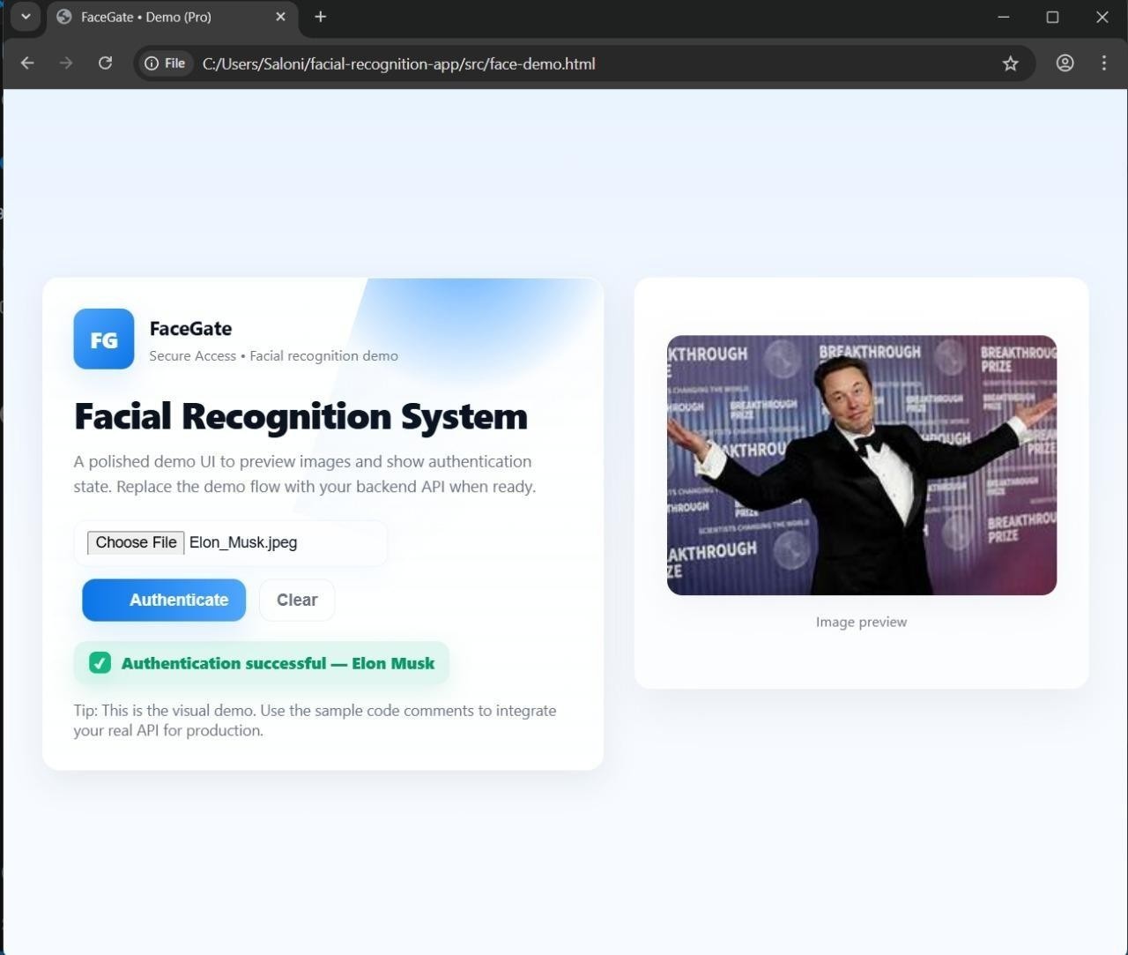

43

